*Work case №5*

*Б.Когут*

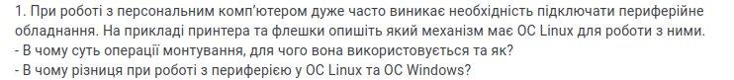When working with a personal computer, there is often a need to connect peripheral devices. Using the example of a printer and a flash driver, explain the mechanism that the Linux operating system uses to work with them.

* What is the purpose of the mounting operation, and how is it used?
* What is the difference in working with peripherals in Linux OS and Windows OS?

Mounting is a key process that ensures the proper integration of external devices into the system for safe and convenient access to their data.

Mounting is necessary for the OS to read and write data in connected devices. In Linux, each device or partition is represented as a filesystem, and mounting allows these filesystems to be added to Os directory structure, such as in folders like /media, /mnt, or another designated location.

The key difference between Linux and Windows in halding peripherals is their approach to automation:

**Automation:**

Windows: Automatically detects and configures most devices (e.g. flash drives, printers) with minimal user setup.

Linux: Often supports automatic connection, but some devices may need manual driver installation or setup, depending on the distribution.

**Mounting drives:**

Windows: External drives automatically appear as new driver.

Linux: Many distributions support automatic mounting, but users can manually mount drivers if needed.

**Configuration flexibility:**

Windows: Focuses no simplicity and ease of use

Linux: Provides more control for advanced users through manual settings.

In short, Windows emphasizes automation, while Linux offers more flexibility but may need additional configuration.

*Я.Трощинський*



2. Connect a USB flash drive and a printer (if possible) to your virtual machine with Linux installed, and use the graphical interface to copy one file from the flash drive to the virtual machine and print it (repeat the same steps, but with another file using commands in the terminal).

To make USB flash drive accessible from Virtual Machine directly, we need to go to settings of VM, “Shared folders”, and add our flash drive as a shared folder.

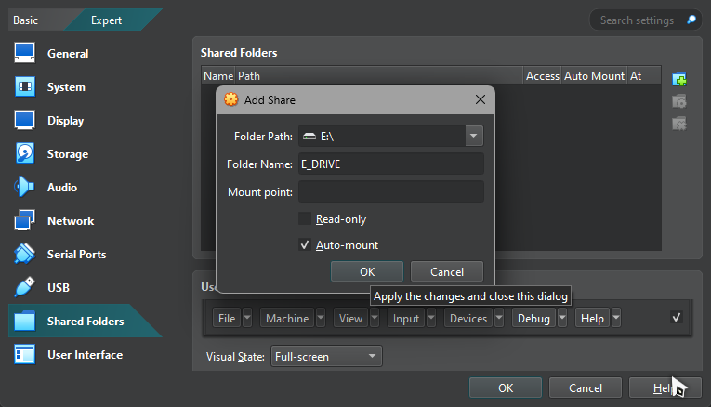

After this we need to allow VM to read and write to and from USB flash, for this we need to go to properties of this drive on Windows Explorer, go to “Sharing” tab, “Advanced Sharing”, and make something like this”:

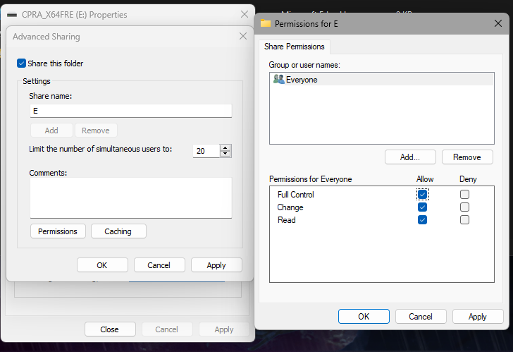

Now we can start machine and using method from Workcase 3 I installed shared folder of my USB drive and can easily access any of images or files on it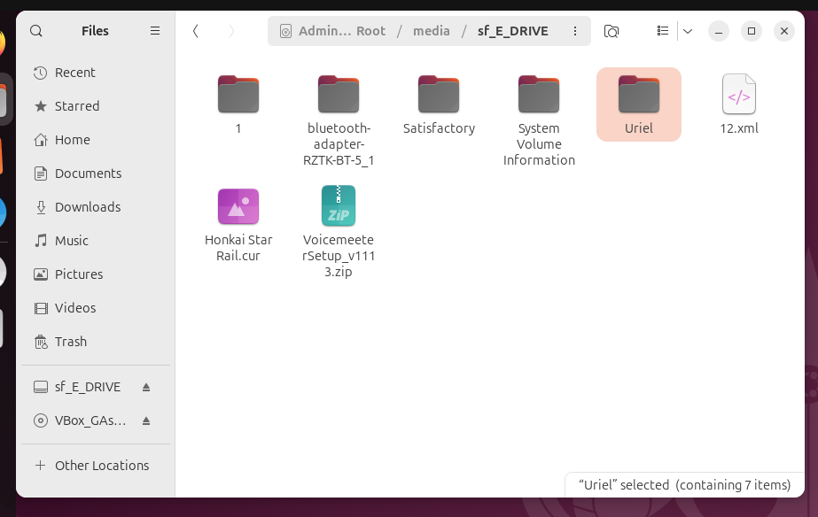

I can also open any of photo files on it



Because I do not have a printer I cannot fulfill an objective of printing a photo, so I will take info mostly from internet:

To print your photo via the usual method we can just open a photo, tap a burger-like button on top, choose “Printer”, modify how it will be printed and just print it.

To do so via command line we can use this command

lp -d *printer_name* 1.jpg

*О.Михайленко*

Conclusion